**Comparing two JSON have the same properties without order:**

**Program**:

let details1 = {name:"Naveen", age:20, email:"naveen@gmail.com", gender:"male"}

let details2 = {email:"naveen@gmail.com",name:"Naveen", age:20, gender:"male"}

let keys1 = Object.keys(details1)

let keys2 = Object.keys(details2)

let flag=true

if(keys1.length === keys2.length) {

for(let e of keys1) {

if(details1[e] !== details2[e])

{

flag=false

break

}

}

}

else {

flag=false

}

flag? console.log("Equal") : console.log("Not Equal")

**Output**:

Equal

—--------------------------------------------------------------------------------------------------------------

**Using rest countries API url, Displaying all countries flag in console:**

**Program:**

<!DOCTYPE html>

<html lang="en">

<head>

<meta charset="UTF-8">

<meta http-equiv="X-UA-Compatible" content="IE=edge">

<meta name="viewport" content="width=device-width, initial-scale=1.0">

<title>Rest countries</title>

</head>

<body>

<h1>Using restcountries API url, displaying all countries flags</h1>

<script>

function reqListener() {

let data = JSON.parse(this.responseText)

for(let i=0; i<data.length; i++) {

console.log(data[i].name.common);

console.log(data[i].flags.png);

console.log("\n");

}

}

const req = new XMLHttpRequest();

req.addEventListener("load", reqListener);

req.open("GET", "https://restcountries.com/v3.1/all");

req.send();

</script>

</body>

</html>

Result:

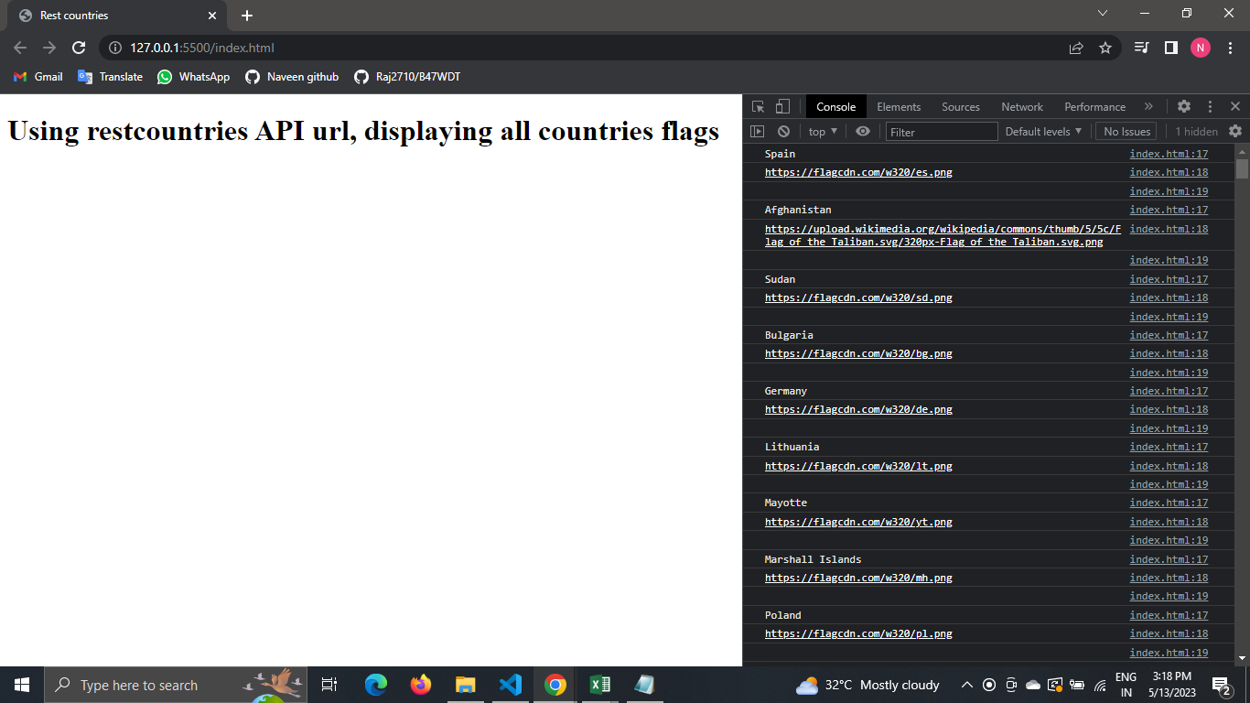

—--------------------------------------------------------------------------------------------------------------

**Using rest countries API url, Displaying all countries names, regions, sub-regions, populations in console:**

**Program:**

<!DOCTYPE html>

<html lang="en">

<head>

<meta charset="UTF-8">

<meta http-equiv="X-UA-Compatible" content="IE=edge">

<meta name="viewport" content="width=device-width, initial-scale=1.0">

<title>Rest countries</title>

</head>

<body>

<h1>Using restcountries API url, displaying all countries names, regions, sub-region and populations</h1>

<script>

function reqListener() {

let data = JSON.parse(this.responseText)

for(let i=0; i<data.length; i++) {

console.log(`Name: ${data[i].name.common}`);

console.log(`Region: ${data[i].region}`);

console.log(`Sub-region: ${data[i].subregion}`);

console.log(`Population: ${data[i].population}`);

console.log("\n");

}

}

const req = new XMLHttpRequest();

req.addEventListener("load", reqListener);

req.open("GET", "https://restcountries.com/v3.1/all");

req.send();

</script>

</body>

</html>

**Result:**

